ECLIPSE ,TOMCAT and SERVLET

First screen is PROJECT EXPLORER ON THE ECLIPSE

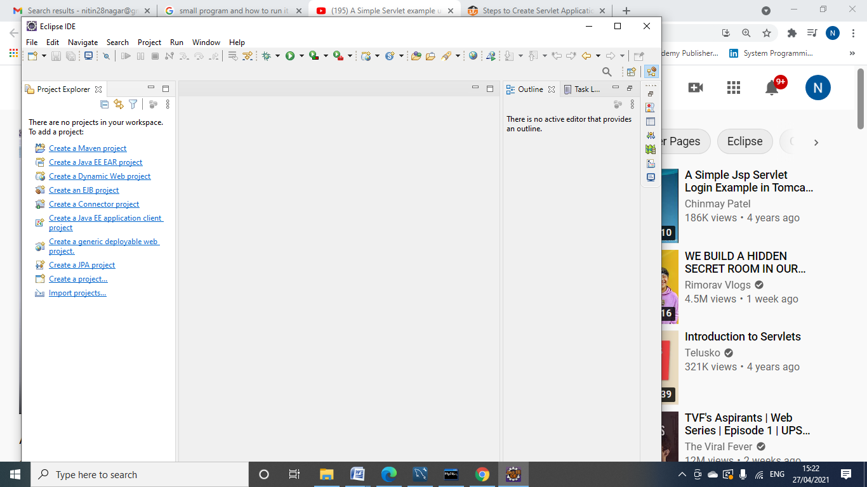

GOTO windows-> preference

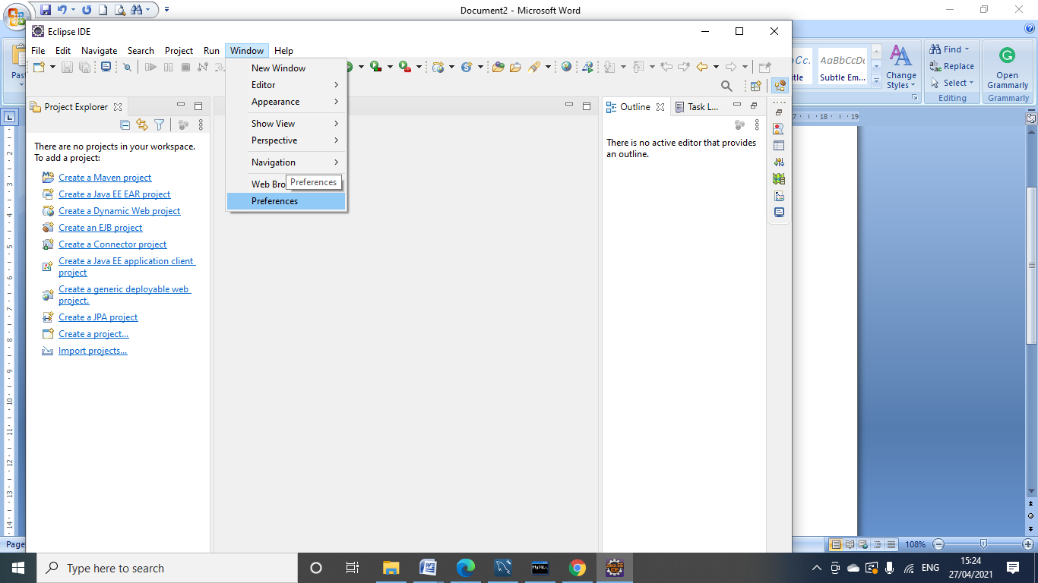

Under servlet-> runtime environment(click on it)

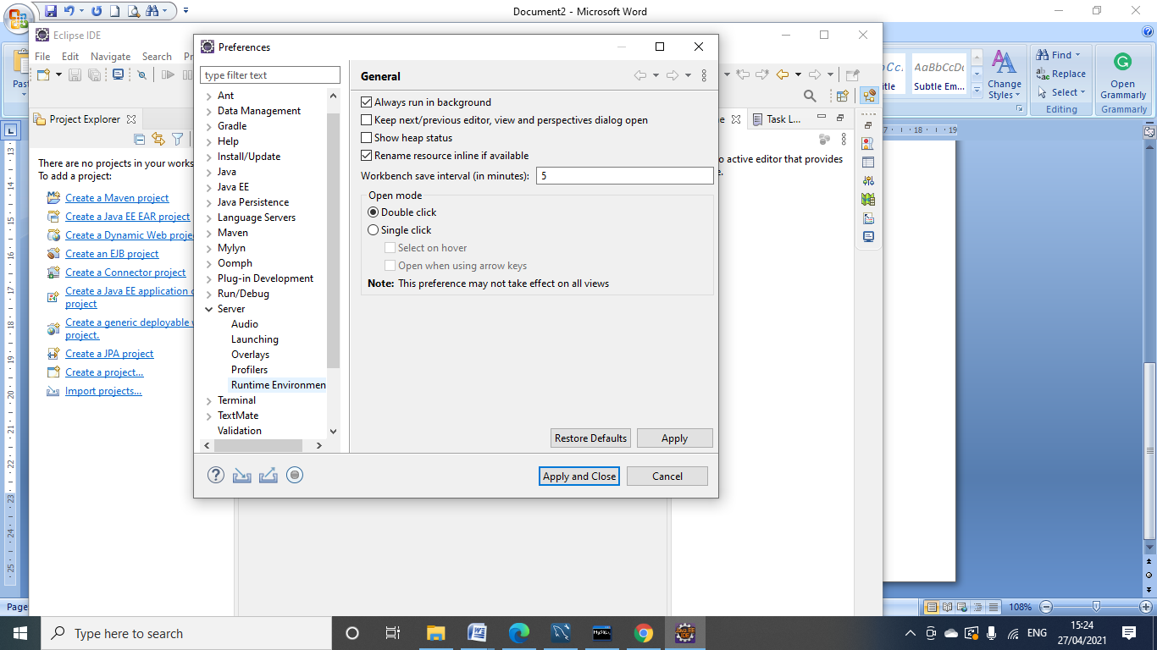

Choose Web server in our case it is Tomcat ( remember that it must be already installed on system, also remember the version of it)

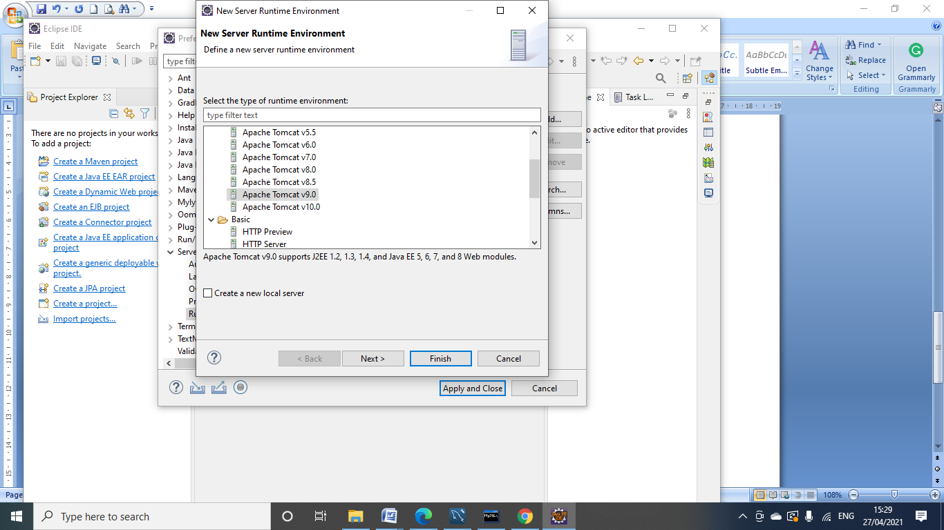

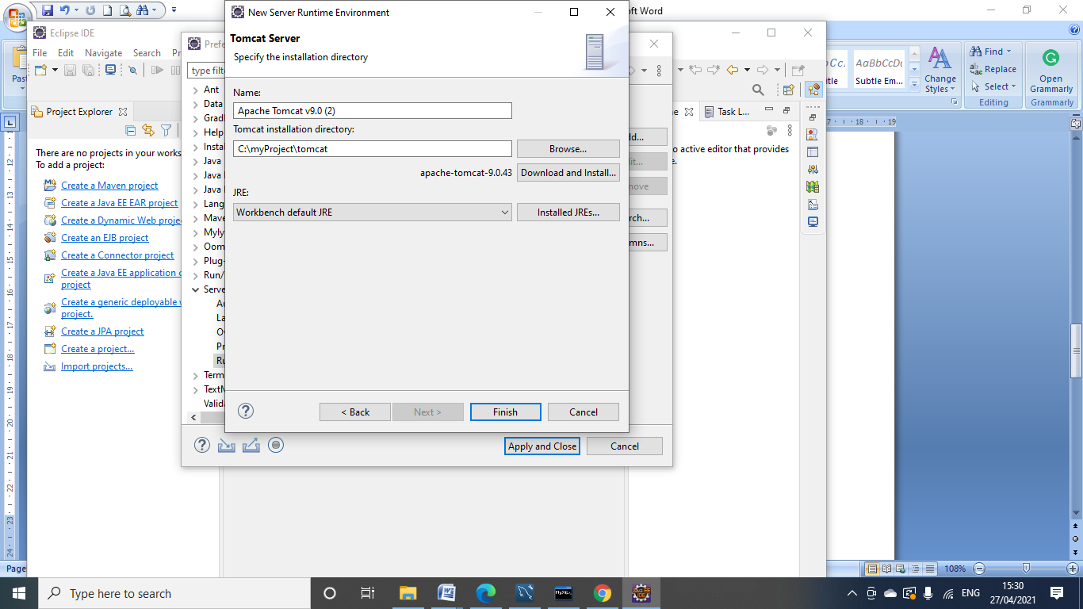

It must the path where is you tomcat located

After clicking finish button, you will find the following window:

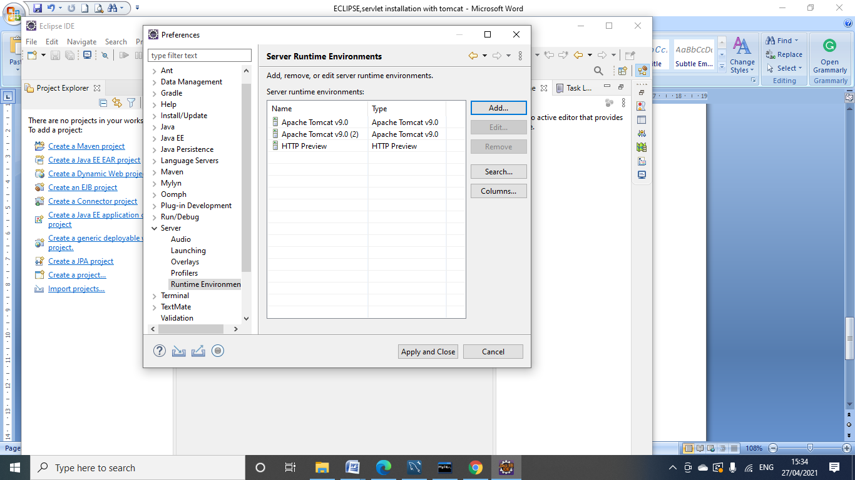

Then Apply and close now eclipse is integrated with tomcat

Now click new-> dynamic web project

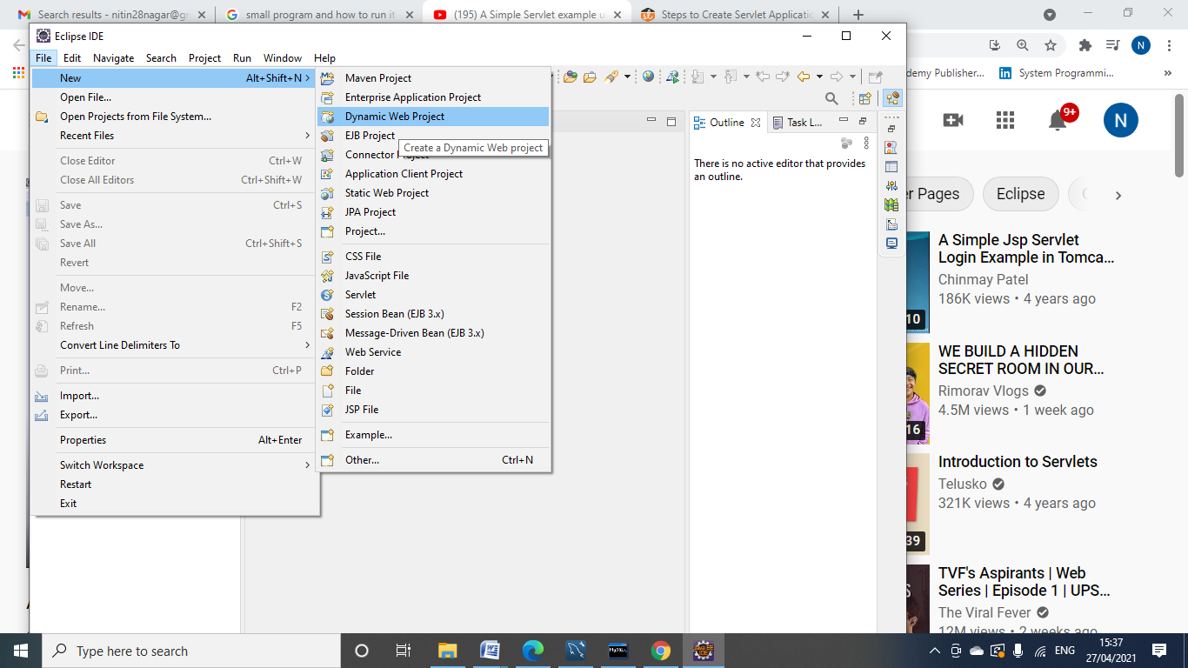

Choose the project name in our case it is PROJECT123 and run time environment will be “Apache Tomcat v9.0” then next

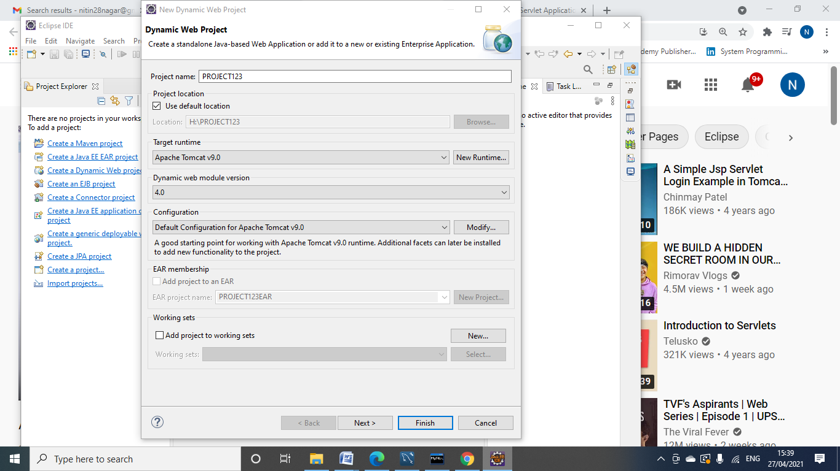

Select generate deployment web.xml descriptor

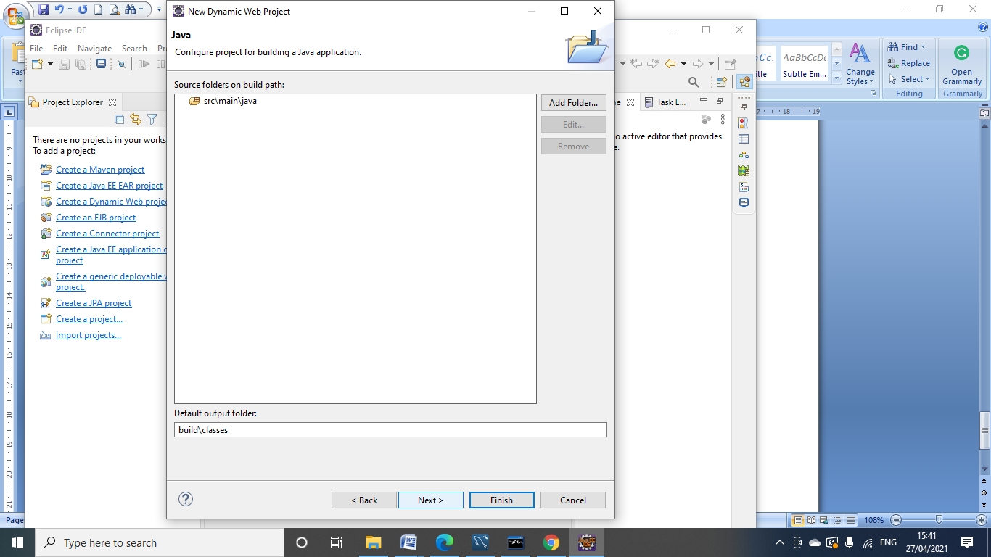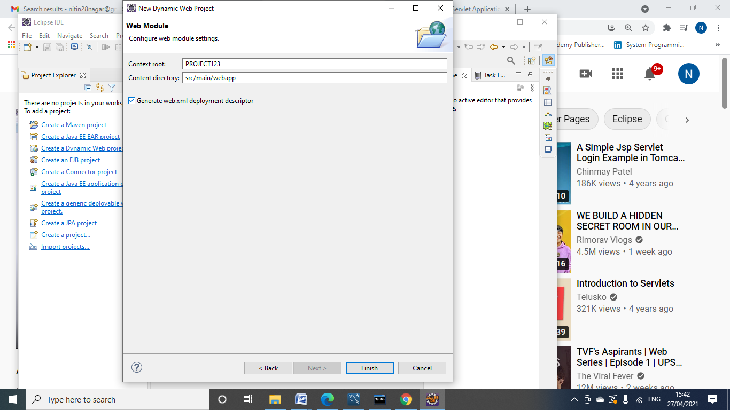

And finish it

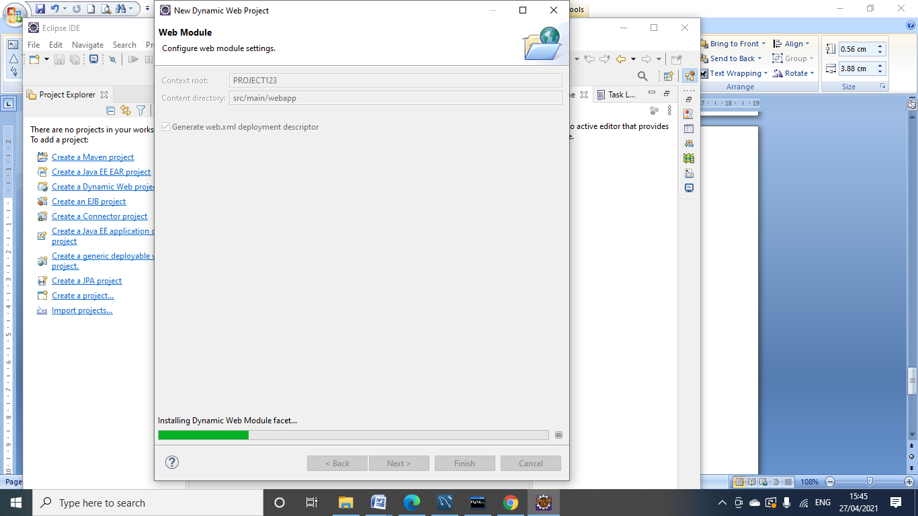

You will find the Folder like this on Project Explorer:

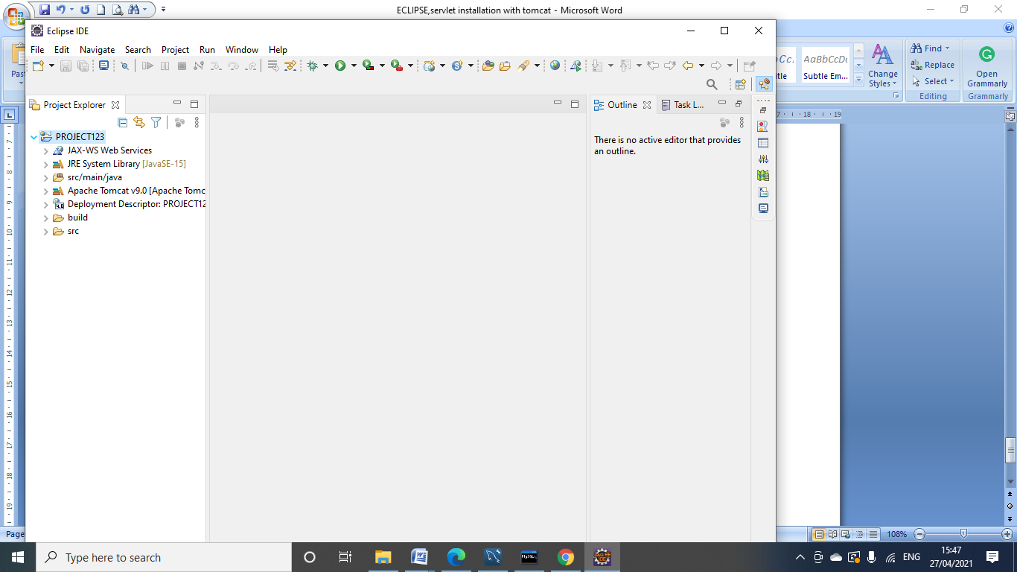

Now just create a simple servlet:

Right click on src/main/java folder

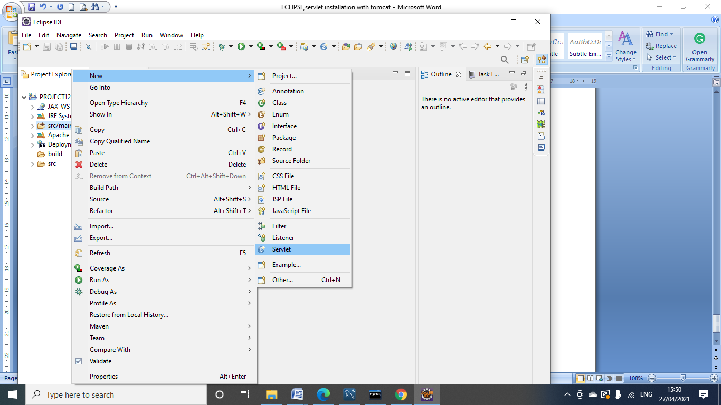

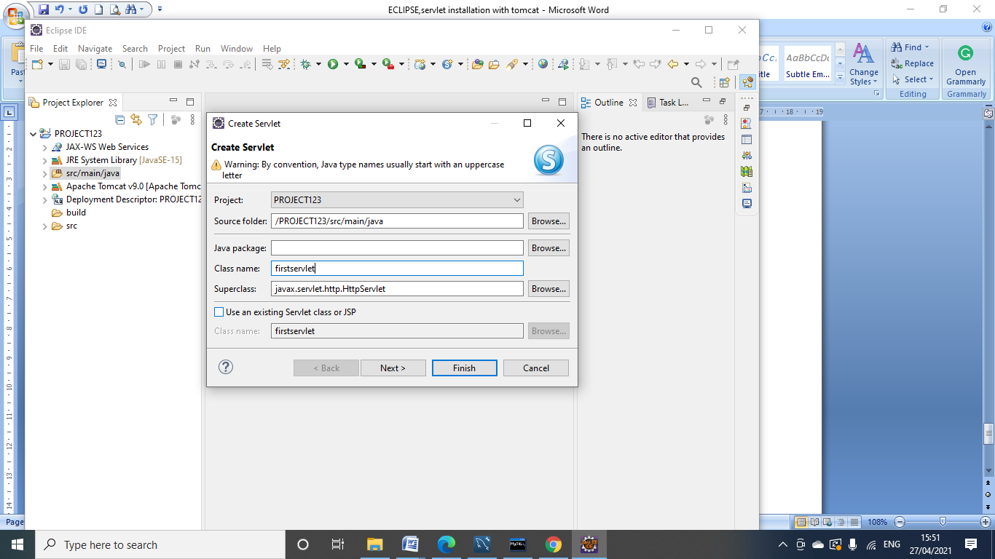

We choose the package name if require, as in our case we don’t want any package and the superclass so we just remove it and click on next button

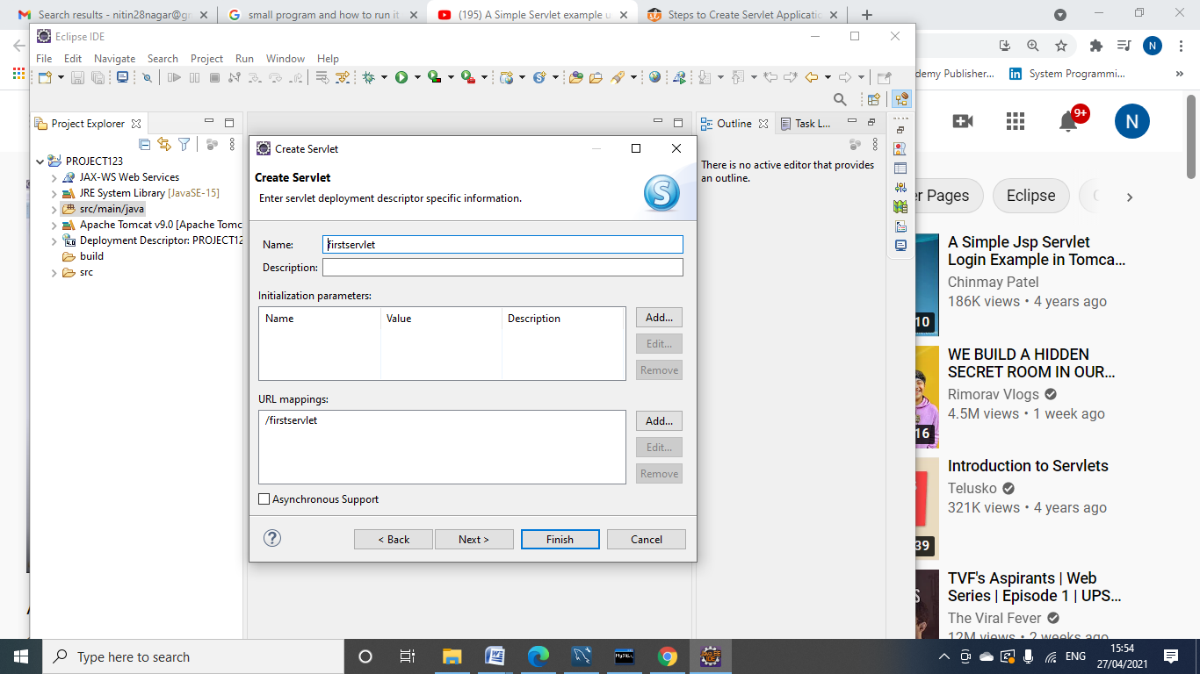

You may also change the URL name but i put the same URL name as my class name. After clicking on finish button the screen will be appear like this

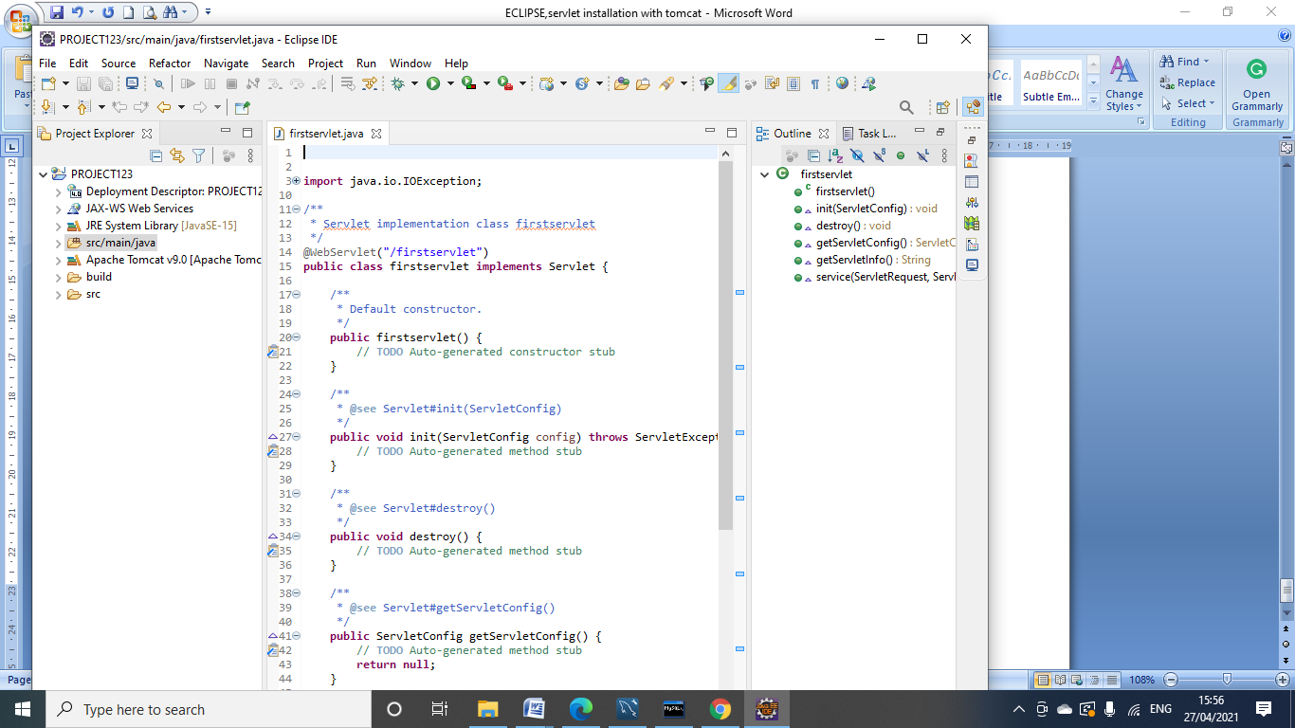

The firstservlet java file appeared with One default constructor

Init(),detroy(), service(),getServletConfig() and getServletInfo methods

This java file also consist package and these package consist of different Interfaces, which we have to implement in servlet programs as per the requirement.

Now we have to perform certain changes in WEB-INF-> web.xml( click on the source tab)

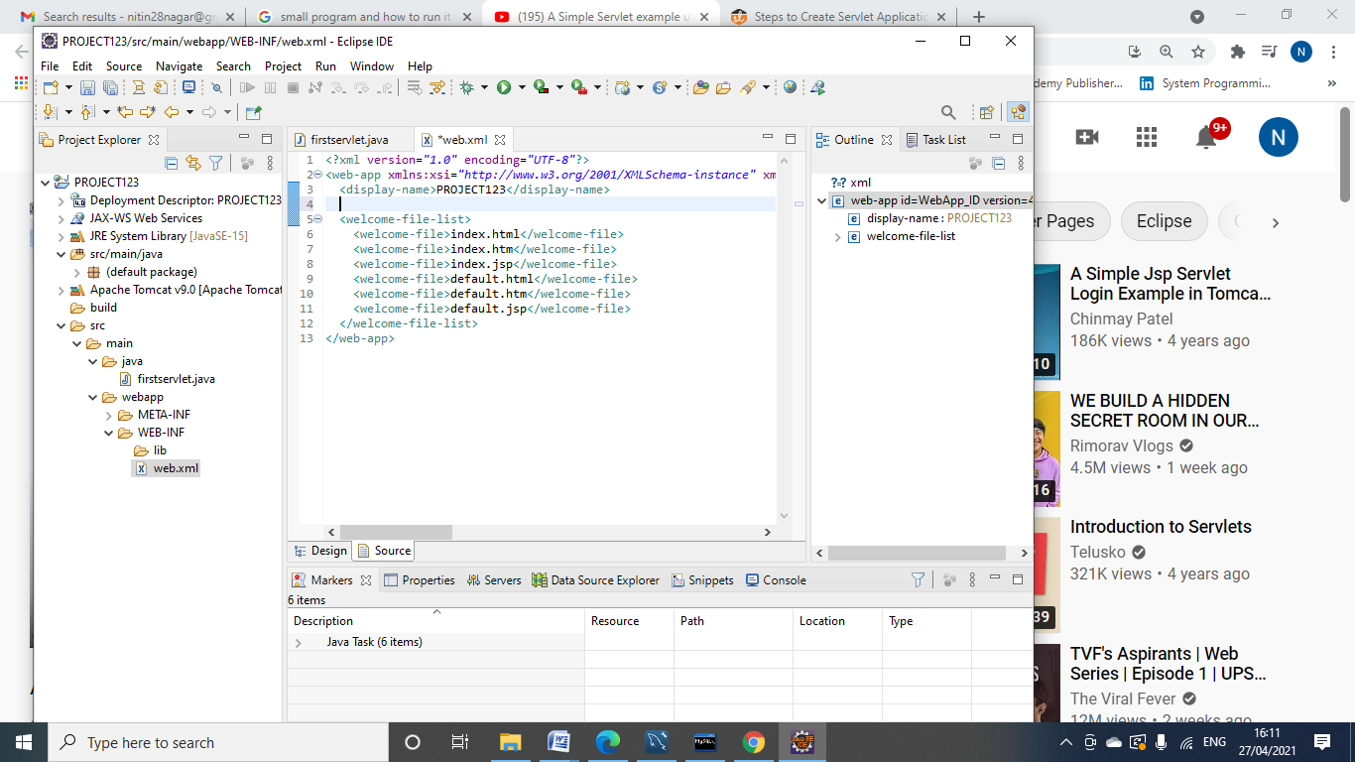

Put these values in web.xml and save it

You can choose ant name for the servlet name:

< servlet>

<servlet-name>first</servlet-name>

<servlet-class>firstservlet</servlet-class>

</servlet>

<servlet-mapping>

<servlet-name>first</servlet-name>

<url-pattern>/firstservlet</url-pattern>

</servlet-mapping>

Now it’s time to change your first servlet

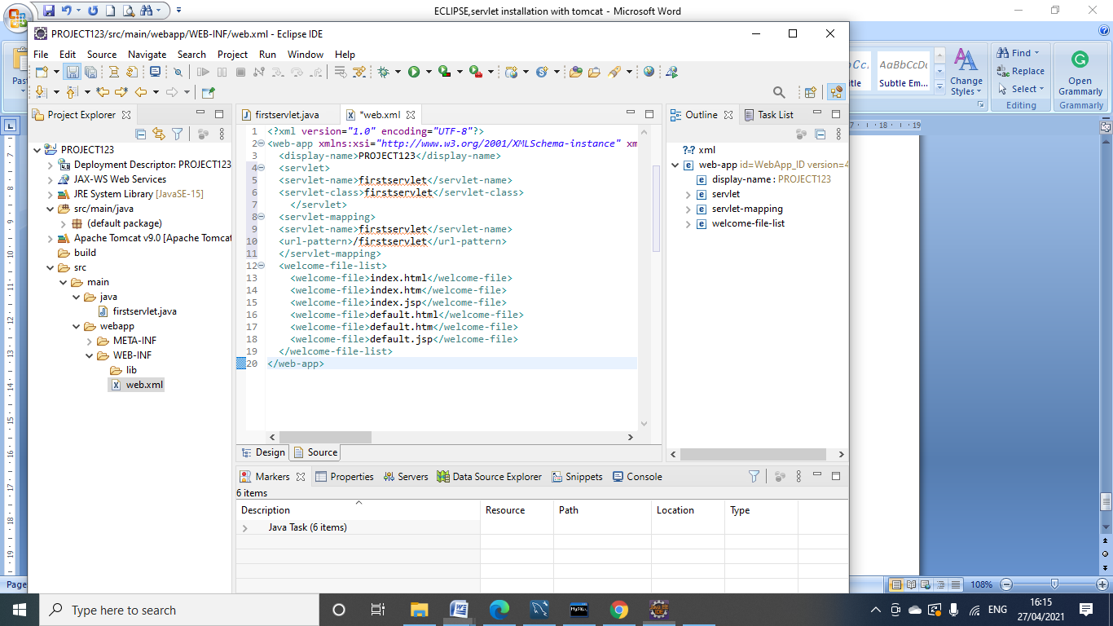

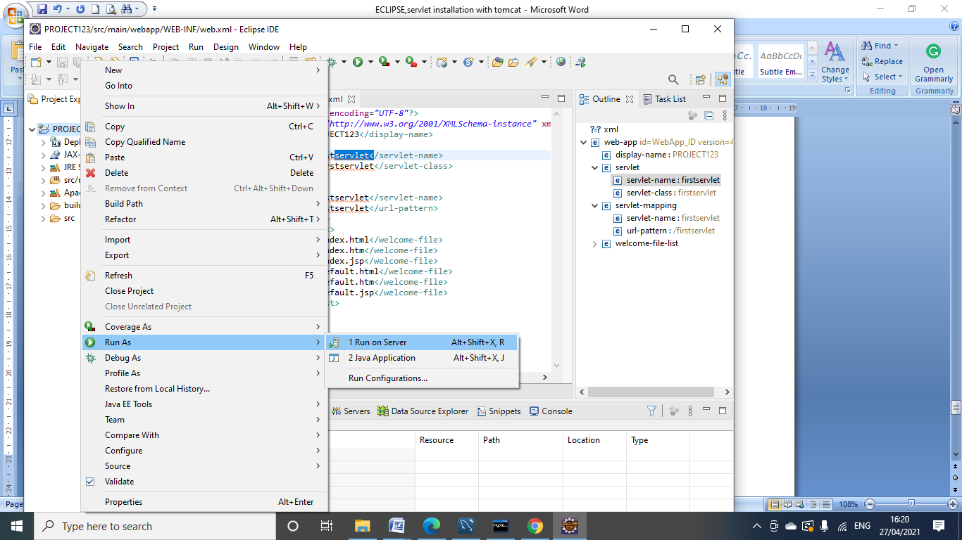

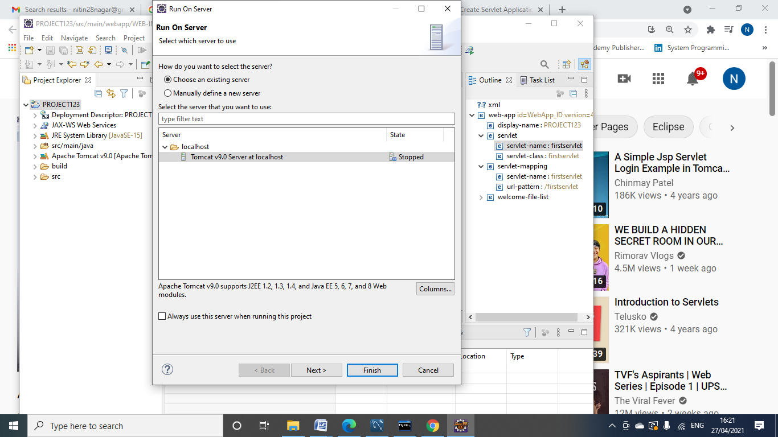

Run on a server there are two options namely

1. Choose an existing server

2. Manually define a new server

Choose second option (Manually define a new server).

